Sunshine Week Social Media
Sunday, March 15 – Saturday, March 21 is Sunshine Week

Share our @NMFOG tweets, Instagrams and Facebook posts all week long to spread the word. Or, create your own using some of our suggested materials below:

Tweets:
It’s #SunshineWeek, celebrate #opengov with @NMFOG & @ABQJournal - post #NM pics with #ShareYourSunshine to win $100 http://wp.me/P4H0I6-jd

Spring in #NM – enjoy the #sunshine, post a photo with #ShareYourSunshine & you could win $100 http://wp.me/P4H0I6-jd
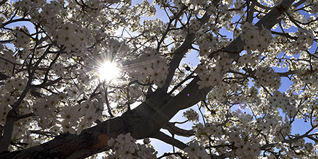

Tweet before March 17 only:
Case-study panel discussion in #SantaFe with @NMFOG & @LWVSFC on #GilaRiver #IPRA suit http://wp.me/P4H0I6-jB #opengov

This #SunshineWeek @NMFOG is looking for the best #NM #photos – post with #ShareYourSunshine http://wp.me/P4H0I6-jd
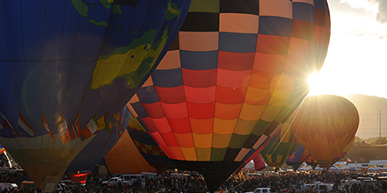

Sunbathing Dog? Sunrise over the #Sandias? @NMFOG wants you to #ShareYourSunshine & win $100 http://wp.me/P4H0I6-jd 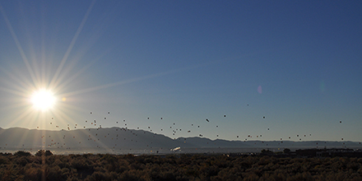

During #SunshineWeek, learn about the importance of #opengov & #transparency – submit questions to @NMFOG or visit www.nmfog.org

From the #Zia symbol to #NM #sunsets, we love our #sunshine - #ShareYourSunshine photos to win up to $100 from @NMFOG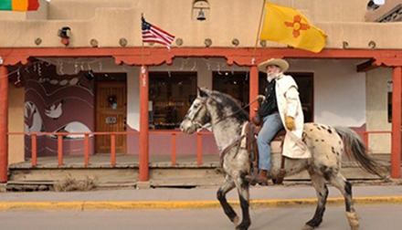

Instagram and Facebook:

Instagram:
Support #opengov #SunshineWeek and you could win up to $100 from @NMFOG. Take a photo of our #NM #sunshine and post it this week using #ShareYourSunshine to enter!

Facebook:
Show off your photography skills and support open government Sunshine Week with @NMFOG (tag us) and the @Albuquerque Journal (tag us). Capture a photo of sunshine in New Mexico and post it with #ShareYourSunshine in the caption to enter to win $100.

Use either of these sharables with either of the captions:
